**Auto loans in U.S**

Auto loans are another significant segment of the U.S. banking sector, providing financing options for consumers to purchase new and used vehicles.

**Types of Auto Loans**

1. **New Car Loans**: Financing for the purchase of new vehicles.
2. **Used Car Loans**: Financing for the purchase of pre-owned vehicles.
3. **Refinancing Loans**: Allows borrowers to refinance their existing auto loans to take advantage of lower interest rates or better terms.
4. **Lease Buyout Loans**: Financing for customers who wish to purchase their leased vehicle at the end of the lease term.

**Key Players**

1. **Commercial Banks**
   * **Bank of America**: Offers competitive rates for new and used car loans, along with a streamlined online application process.
   * **Chase Bank**: Provides auto loans with flexible terms and a dedicated auto lending division, Chase Auto.
2. **Credit Unions**
   * **Navy Federal Credit Union**: Known for offering lower interest rates and flexible terms for military members and their families.
   * **PenFed Credit Union**: Provides competitive rates for both new and used vehicles, along with member-friendly services.
3. **Auto Finance Companies**
   * **Ally Financial**: A leading auto finance company that provides a range of financing and leasing options through dealerships.
   * **Ford Credit**: The financial arm of Ford Motor Company, offering financing and leasing options for Ford and Lincoln vehicles.
4. **Online Lenders**
   * **Light Stream (a division of SunTrust Bank)**: Offers competitive rates and quick funding for auto loans, with an entirely online application process.
   * **Carvana**: Provides a unique online car buying experience with financing options directly through its platform.

### Regulatory Environment

1. **Truth in Lending Act (TILA)**: Requires lenders to provide clear and detailed information about loan terms, including the APR, loan amount, and total cost.
2. **Equal Credit Opportunity Act (ECOA)**: Prohibits discrimination in lending based on race, color, religion, national origin, sex, marital status, or age.
3. **Consumer Financial Protection Bureau (CFPB)**: Oversees auto lenders to ensure fair lending practices and compliance with federal regulations.

### Current Trends

1. **Digital Transformation**: Increasing use of online platforms for loan applications, approvals, and management. Companies like Light Stream and Carvana are at the forefront of this trend.
2. **Interest Rate Sensitivity**: Auto loan interest rates are influenced by Federal Reserve policies and overall economic conditions. Recent trends show a sensitivity to changes in the federal funds rate.
3. **Loan Terms Lengthening**: There is a trend towards longer loan terms (up to 84 months), which lowers monthly payments but can increase the total interest paid over the life of the loan.
4. **Subprime Lending**: Lenders offer auto loans to subprime borrowers (those with lower credit scores) but at higher interest rates to offset the increased risk.

### Examples of Auto Loan Products

1. **Bank of America**: Offers competitive rates for new and used car loans, along with a streamlined online application process and rate discounts for Preferred Rewards members.
2. **Chase Auto**: Provides financing for new and used cars purchased from dealers, as well as options for loan refinancing and lease buyouts.
3. **Navy Federal Credit Union**: Known for lower interest rates and flexible terms for military members and their families, along with discounts for automatic payments.
4. **Light Stream**: Offers unsecured auto loans with no fees, competitive rates, and quick funding, suitable for both new and used cars, as well as classic cars.

### Managing Market Fluctuations

#### Lenders' Strategies:

1. **Risk-Based Pricing**: Adjusting interest rates based on the borrower’s credit risk.
2. **Portfolio Diversification**: Offering a range of loan products to spread risk across different types of borrowers and vehicles.
3. **Loan Loss Provisions**: Setting aside reserves to cover potential loan defaults, particularly during economic downturns.
4. **Securitization**: Bundling auto loans into asset-backed securities (ABS) to sell to investors, transferring some of the risk off their balance sheets.

#### Borrowers' Strategies:

1. **Refinancing**: Refinancing existing auto loans to take advantage of lower interest rates when available.
2. **Credit Improvement**: Working on improving credit scores to qualify for better rates and terms.
3. **Down Payments**: Making larger down payments to reduce the loan amount and monthly payments.
4. **Shorter Loan Terms**: Opting for shorter loan terms to reduce the overall interest paid.

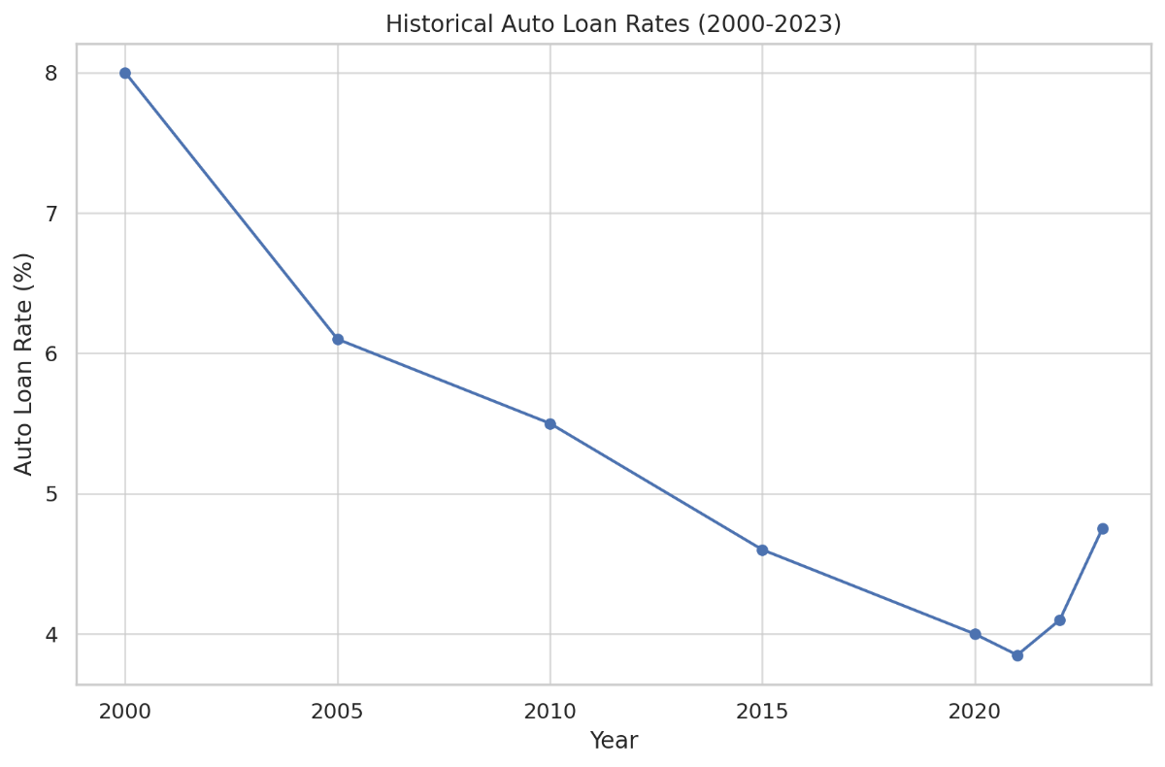

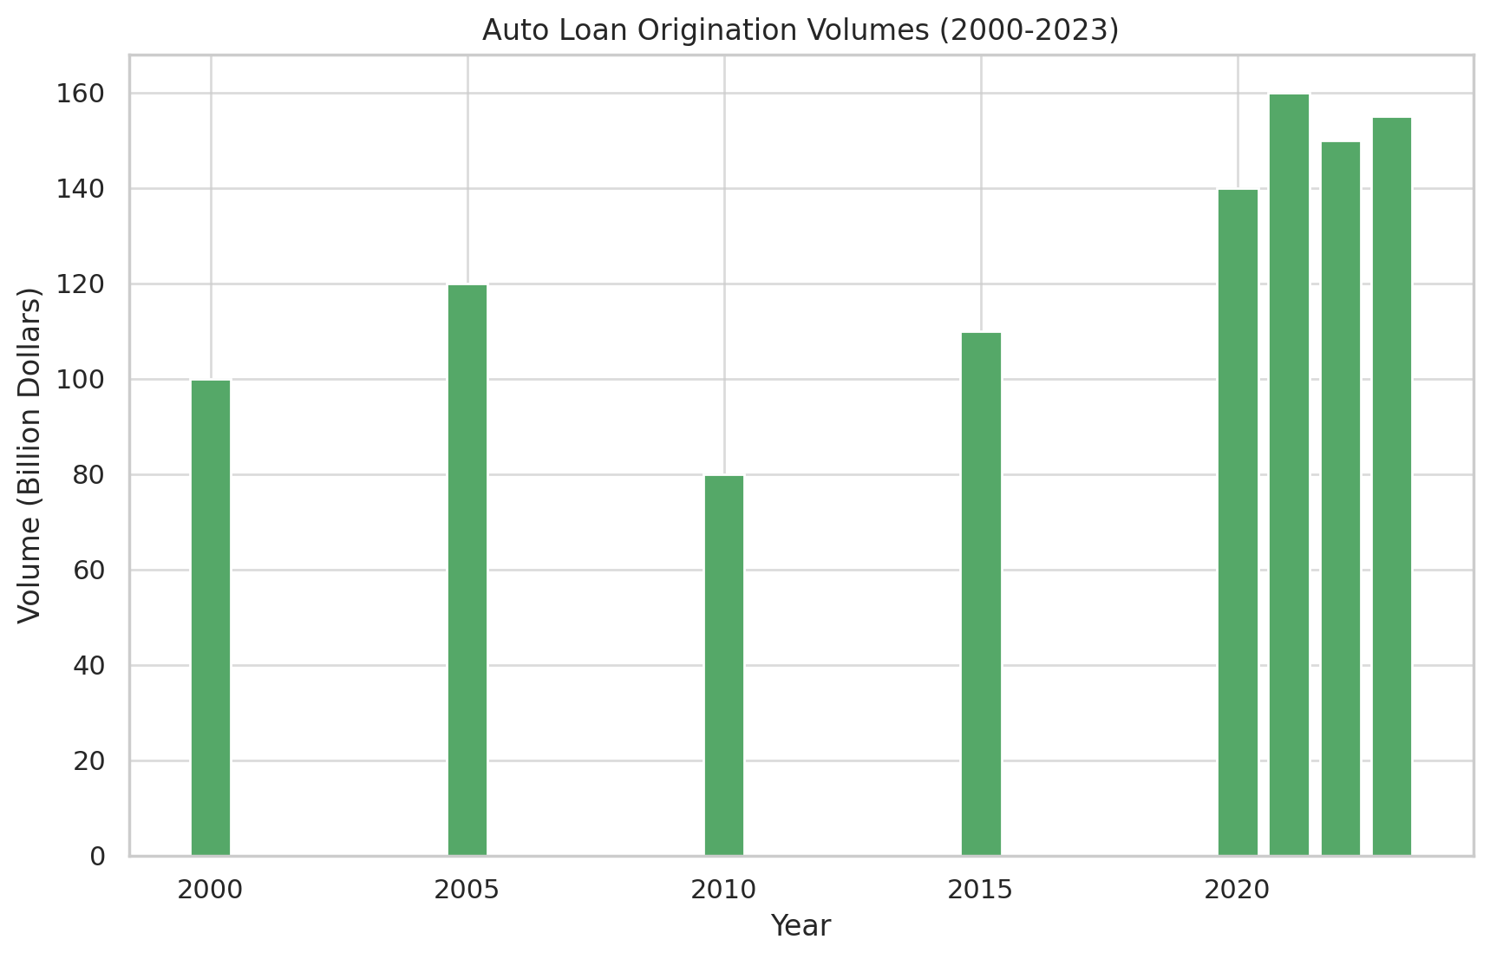

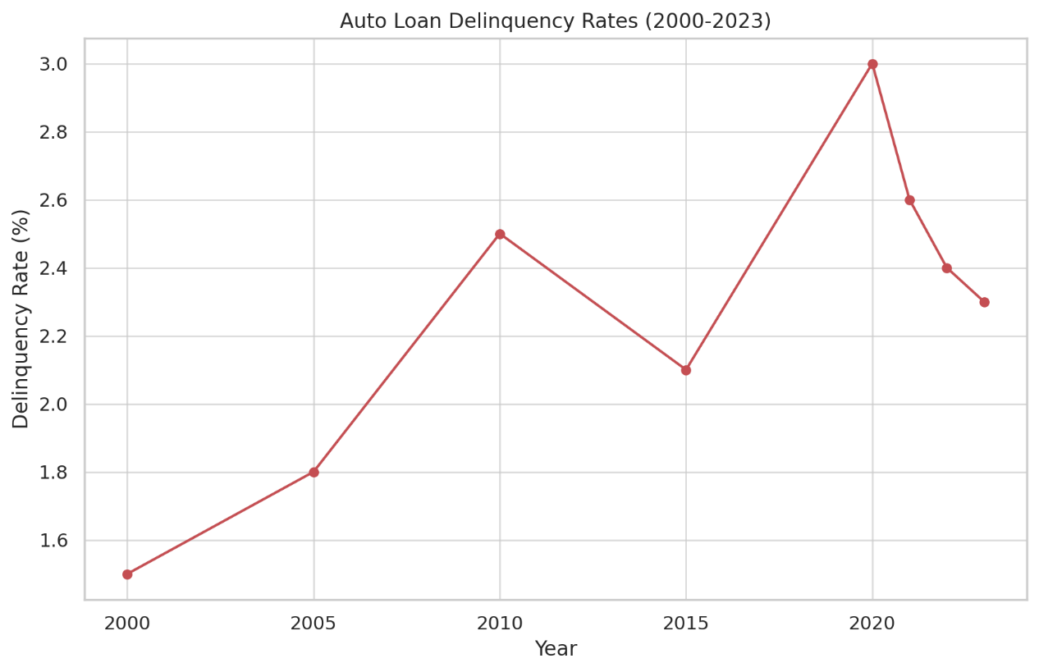

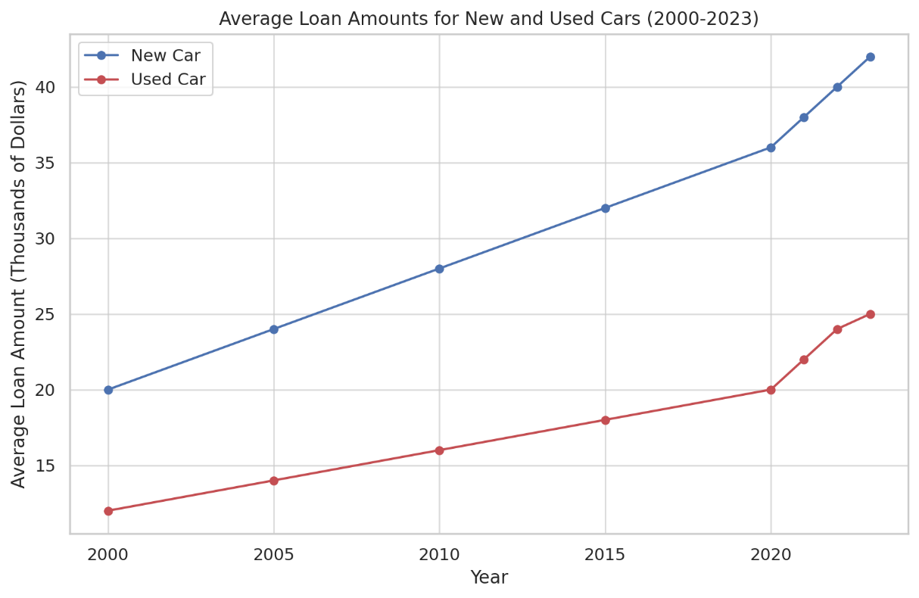

• H**istorical Auto Loan Rates (2000-2023)**:

* Auto loan rates have fluctuated over the past two decades, with a notable decrease in recent years, reaching as low as 3.85% in 2021 before rising again to 4.75% in 2023.

• **Auto Loan Origination Volumes (2000-2023)**:

* Auto loan origination volumes have generally increased, with a significant rise in recent years, reaching $160 billion in 2021 and stabilizing around $155 billion in 2023.

• **Auto Loan Delinquency Rates (2000-2023)**:

* Delinquency rates for auto loans have shown variability, peaking at 3.0% in 2020 due to economic impacts before decreasing to 2.3% in 2023.

• **Average Loan Amounts for New and Used Cars (2000-2023)**:

* The average loan amount for new cars has steadily increased from $20,000 in 2000 to $42,000 in 2023.
* Similarly, the average loan amount for used cars has risen from $12,000 in 2000 to $25,000 in 2023.